**Homework 8**

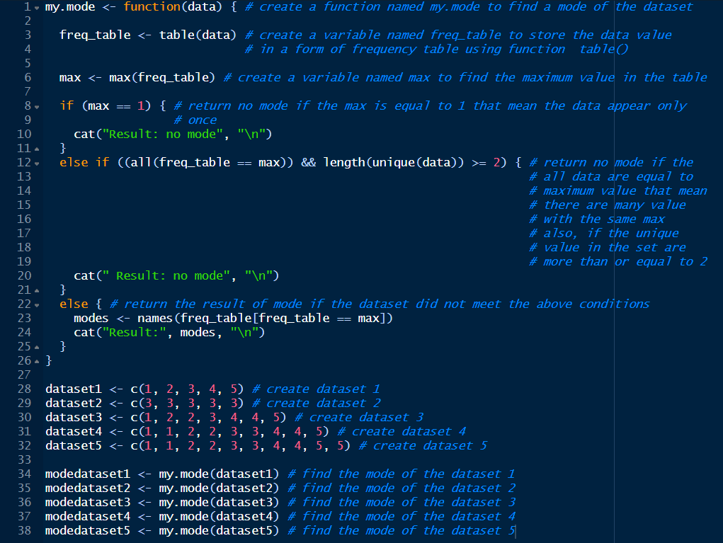**Code:**

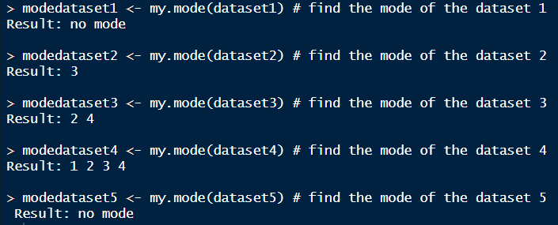**Result:**

**Conclusion:**

From the experiment, my.mode is the function that demonstrates how to find the mode using the maximum value in that dataset. The mode of dataset 1 is no mode, dataset 2 is 3, dataset 3 is 2 and 4, dataset 4 is 1, 2, 3, and 4, and dataset 5 is no mode. In my opinion, it will have no mode when all values occur at once or occur more than or equal to 2 with the same maximum value, and the others will have the mode.